Pop up Pirate  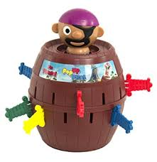  Basic Level  Limited verbal skills  Ages: Pre-K to 5th grade | Pieces included in visuals  Rules for game  - Insert the pirate into the barrel  - Students take turns spinning the spinner  - Using the visuals provided, student will select the color from the visual and tell the group what color they got  - The student then inserts the sword into the barrel until the barrel pops the pirate up  NOTE: THE PIRATE SHOOTS UPWARDS  Additional Tips and Ideas  - Have the student request the pieces to the game at the beginning (Asks for the barrel and the pirate)  - Have the student tell other student in the group it’s their turn  - When finished with the game have the student indicate they are “Finished” playing the game

